Lightweight Deep Learning Model Architecture for Affective State Recognition from Wearable Physiological Sensors
Rajeev Nayan, Indrajeet Mondal, Susmita Bera, Suseta Datta, Debrupa Pal, and Subhasree Bhattacharjee
Dept. of Computer Application, Narula Institute of Technology, Kolkata, India
nayanrajeev2624@gmail.com, indrajeetmondal120703@gmail.com, susmita.bera.227@gmail.com, suseta.datta@gmail.com, dppalit@gmail.com, bhattacharjeesubhasree@gmail.com
Abstract. In this fast changing world, health of an individual has started taking a huge toll. The industrial leaders are pushing for longer working duration. People are generally more stressed from all the uncertainty ever since the post-covid era. Those who suffered from covid-19 also have reported weaker lung function, thus reducing the oxygen into blood, leading to more health issues such as depression, anxiety, stress, etc. In such a phase of life, monitoring health stats on a regular basis has been a challenge leading to quite a few avoidable life causalities. This has led to the rise of smart bands, smartphones using in built sensors to monitor the health stats of the user. While these modern devices provide with constant monitoring but fail to provide accurate prediction and preventive situations, thus the need to integrate machine learning or deep learning algorithms to analyse these data and provide insightful analysis to the user to stay healthy. Modern implementations of analysing such time series data includes hybrid models of CNN+LSTM architecture which are quite heavy, whose size can vary from around 2M to 6M parameters, longer epoch time while training, higher activation memory because of the higher hidden layers (256/512) in them. The main aim of this research was to make a model much lighter than the ones present as SOTA at the cost of minimal performance drop. For this goal, the architecture that was used consists of CNN+BiGRU. It uses a shallow CNN for local temporal patterns from multichannel physiological signal, while the two layered BiGRU with a hidden size of 128 per direction uses this data provided by the CNN to capture both past and future temporal dependencies within each window which is crucial for modelling. The resultant model has reached competitive performance with ~70-85% fewer parameters, demonstrating a favourable efficiency-accuracy trade off suitable for real-world wearable deployments.
Keywords: wearable sensors, affective computing, CNN-BiGRU, physiological signals, stress detection, deep learning

Introduction
Designing deep learning models for wearable physiological data requires balancing representational capacity with computational efficiency, particularly for deployment on resource-constrained edge devices. While hybrid CNN–LSTM architectures have become a de facto standard for modeling multivariate physiological time-series due to their ability to capture spatial correlations and long-term temporal dependencies, such models are often characterized by large parameter counts, high memory consumption, and long training and inference times. These limitations prevent practical applicability in real-world wearable health monitoring systems.
To counter the heavy LSTM architecture, BiGRU models have been proposed in this research. GRUs employ a simplified double gate mechanism as compared to the resource hungry triple gate mechanism in LSTMs. The bidirectional data flow helps the neural network to learn about future patterns from past data and vis-a-vis.
This architecture has a shallow convolutional front-end for extracting cross-channel features from multichannel physiological signals, and a two-layer BiGRU for temporal sequence modeling. A multi-head self-attention mechanism is further employed to selectively emphasize informative temporal segments within each window, enabling the model to focus on critical physiological transitions associated with affective state changes. The resulting representations are aggregated and classified using a compact fully connected head.
This design achieves a favorable efficiency–accuracy trade-off, reducing the overall parameter count by approximately 70–85% compared to conventional CNN–LSTM models while maintaining competitive performance. Such efficiency makes the proposed CNN–BiGRU architecture particularly well suited for continuous stress monitoring and affective state recognition in wearable and edge computing environments.

Literature Survey
Wearable devices in the healthcare industry have become a significant development that offer constant monitoring, but for better patient results, on device analysing the monitored data we need to support using other technologies such as blockchain, machine learning or deep learning algorithms, IOT, etc. Following are some of the contributions made by other researchers in this direction:
Alattar and Mohsen [1] conducted a survey “A Survey on Smart Wearable Devices for Healthcare Applications” to study the use of smart wearable devices in healthcare. The data collected by their survey includes how these devices were powered, how they provide connectivity with other devices, and how comfortable are they for the patients to wear. Although the study helps in deciding the hardware and their respective deploy ability for the general masses but lacks in-depth clinical testing to confirm their efficiency.
Zeqiang Xie, Zijian Li, and XinbingLiu [2] introduced SHARP: Blockchain-Powered WSNs for Real-Time Student Health Monitoring and Personalized Learning. This research proposed a wireless sensor network that uses blockchain technology for secure and tamper-proof data through deep neural network (DNN), which provides with high accuracy classification of health states such as fatigue, stress, etc. Furthermore, reinforcement learning (RL) is used to deliver personalized health and learning suggestions, adapting with new data in the future. The system achieved a 94.2% F1-score in simulated classroom environments. However, despite the technological strength, the model’s dependence on simulations raises concerns about scalability in real life scenarios along with acceptance rate amongst students may vary drastically across different geographies.
Rita Ribeiro, Rafael Martins, Hugo Pereira, Vítor Crista, and others [3] carried out a systematic review on continuous movement monitoring at home through wearable devices. These systems support the management of chronic diseases and promote personalized healthcare by providing actionable insights. RHM reduced hospital visits, improved patient management, and supports proactive care. However, challenges still persist in terms of data privacy, device usability, patient compliance, etc.
Dilip Kumar [4] explored a data analytics approach for health monitoring using wearable sensors. The research methodology involved collecting medical stats include blood pressure, pulse rate, and body temperature with analytics implemented in Proteus Professional Software. However, as the simulations were validated in a virtual controlled environment, it’s scalability and reliability remain untested.
Hossain and Muhammad [5] investigated integrating wearable IoT devices with predictive analytics for monitoring health stats remotely. Their methodology involved streaming real-time physiological data from the sensory devices to cloud based machine learning models for detecting patient condition and check for anomalies if any or if there is any such possibility in the near future. Even though the architecture was practical but problems related to real-time data processing and confidence in AI interpretability were identified.
Khan et al. [6] proposed an AI-driven real-time health monitoring system using wearable sensors for predictive analytics. Physiological signals such blood glucose, SpO2, and heart rate were analysed using both traditional machine learning models (Random Forest, SVM) and deep learning models (CNN, LSTM). The system demonstrated good early prediction of disease and reduced hospital admissions. However, the main problem faced by the authors was the requirement for broader population-level validation and seamless integration with healthcare IT systems.
Mahabub et al. [7] presented a comprehensive review of wearable technologies for health monitoring, focusing on consumer and medical-grade devices. Their studied sensor technologies including photoplethysmography (PPG) and galvanic skin response (GSR). The authors also explored future trends involving multi-modal inputs, blockchain based data sharing for security purpose, and AI driven interventions. However, it is limited due to it’s reliance on secondary data without experimental validation.
Parasuraman et al. [8] reviewed challenges of collecting data from mobile devices in connected health systems. Highlights issues such as data interoperability, heterogeneous sensor formats, and large-scale real-time data integration. This work underscores the importance of robust infrastructure alongside wearable hardware.
Ave [9] examined computational approaches for the analysis of wearable health data and early disease detection, and deep learning models such as the convolutional neural network and the recurrent neural network to continuous physiological data streams. Although results demonstrate effective anomaly detection, challenges including noisy sensor data, inconsistent sampling rates, and privacy concerns were emphasized.
Min et al. [10] explored skin-interfaced wearable sweat sensors for precise medicine applications. This work focused on electrochemical sensing of sweat biomarkers such as glucose, lactate, and electrolytes using flexible, biocompatible electronics. They study noted challenges in correlating sweat biomarkers with blood biomarkers and maintaining sensor stability under varying conditions.
Recent studies have shifted from traditional feature-based machine learning to end-to-end deep learning models for predictive analysis due their robustness of dealing with anomalies. Hybrid CNN-LSTM architecture has been widely accepted due to their ability to capture spatial features and long-term temporal dependencies. The main trade off with this deep learning model architecture is being resource hungry post deployment thus contributing towards high cost in computation while model training, evaluation, and deployment. Thus, highlighting the need for lightweight and efficient deep learning architectures.

Research Methodology

Data Preprocessing
The WESAD datasets comprises of physiological signals collected from chest-worn (RespiBAN) and wrist-worn (Empatica E4) sensors across 15 subjects for 4 affective states of baseline, stress, amusement, and meditation. The pipeline developed addressed multi-modal sensor fusion and temporal alignment challenges inherent in heterogeneous data.
Raw data for each subject were extracted from pickle files containing chest sensors sampled at approximately 700 Hz (ECG, EDA, respiration, temperature, and 3-axis accelerometer) and wrist sensors sampled at approximately 32 Hz (EDA, temperature, and 3-axis accelerometer). The wrist and chest signals captured were of different frequencies, leading to discrepancies in the length of information gathered per unit of time. This issue was addressed by up-sampling wrist signals with those of chest signals using linear interpolation.
Feature engineering was applied to the accelerometer data from both sensors. Three axis-accelerometer signals (x,y,z) were transformed into scalar magnitude features using the Euclidean norm (√(x² + y² + z²)). This reduced dimensionality from three features per accelerometer to one while preserving movement intensity information.
All physiological signals were then down sampled to a uniform sampling rate of 32 Hz using block-based averaging. Block-based averaging preserved signal characteristics and reduced high-frequency noise while significantly reducing computational requirements for subsequent deep learning operations.
This gave a sampling rate of 32 Hz that was sufficiently faithful to record physiological dynamics (heart rate variability, breathing patterns, electrodermal responses) and permitted model training times to be practical.
Each of those eight physiological channels would be transformed into a single multi-modal feature matrix. This described a stress complement with respect to various physiological areas and this gave the model a complete picture of the way the body responds to stress.
A sliding window segmentation method was applied to generate fixed length temporal sequence that is compatible with deep learning. The window of the continuous signal streams was taken as 60s with 50% overlap, producing signal segments of 1920-time steps (32 Hz x 60 s) on each of the 8 channels. The 50% overlap augments the amount of training samples as well as guarantees the temporal shifts among affective states are covered smoothly.
A 70% cutoff was used to assign window-level labels. The most common label of the constituent samples in each window was identified and only then the label assigned to the window when it contained at least 70% of the samples in that window. Windows that had this threshold were classified as baseline. This approach makes sure that only unambiguous segments with a clear affective state are model trained to decrease label noise that may hurt classifier performance.
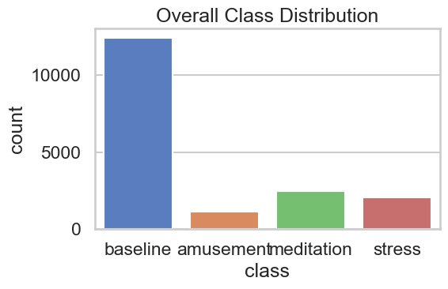
FIGURE 1. Overall Class Distribution
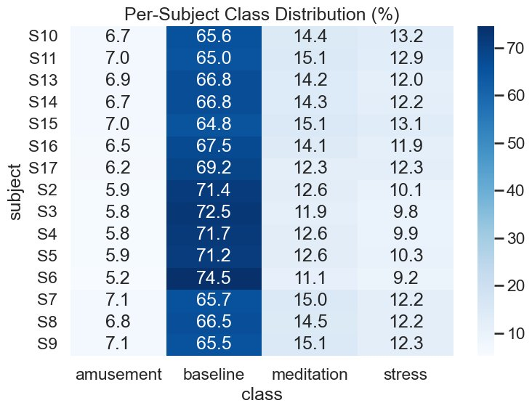
FIGURE 2. Per-Subject Class Distribution (%)

Model Architecture
The model architecture comprising of Convolutional Neural Network (CNN), Bidirectional Gated Recurrent Units (BiGRU), and multi-head self-attention mechanisms. It then processes pre-processed 60s windows through 5 sequential stages: CNN-based feature extraction, bidirectional recurrent processing, layer normalization, multi-head attention, and classification.
In the CNN front-end, two sequential 1D convolutional layers that have 64 filters and a 3-kernel size are used to extract spatial features. This element acquires inter-channel interaction patterns. Activations of ReLU are non-linear whereas dropout with probability 0.2 regulates the network. The CNN changes the raw signals of more than one model into 64 and learned feature representations which represent physiological correlations.
The two-layered BiGRU with 128 hidden layers takes the sequences in both forward and backward temporal directions and concatenates the results to generate the 256-dimensional representations at each time step. The forward pass records gradual physiological variations whereas the backward pass determines the contextual patterns and the anticipatory responses. The inter-layer dropout 0.3 helps to avoid overfitting due to a small subject pool and the later layer normalization stabilizes training by normalizing the scales of the activations.
The self-attention mechanism computes relevance scores between all-time step pairs, enabling the model to emphasize critical moments such as stress peaks, or sudden physiological transitions while de-emphasizing baseline periods.
Multiple attention head learn complementary importance patterns. This selective focus mechanism allows the model to extract discriminative features from heterogeneous 60s windows where stress indicators may appear at different temporal locations.
Temporal mean pooling aggregates the attention-weighted sequence into a fixed-length representation by averaging across time steps. The classifier head consists of two fully connected layers with ReLU activation and dropout mapping pooled with initialized using Kaiming initialization for convolutional and linear layers and Xavier initialization for GRU weights, following best practices for their respective functions.

Training and Evaluation
Leave One Subject Out (LOSO) was used for training and evaluation. In each fold, one subject was used as test set while remaining were used for training the model. This procedure is repeated with each subject serving as the test subject at least once.
Data was normalized using z-score standardization. Channel wise mean and standard deviations were calculated by streaming computation to maintain memory efficiency, then applied to normalize all signals to zero and unit variance. This fold-specific normalization prevented information leakage from test subjects while ensuring consistent input distributions across channels with inherently different scales.
The WESAD dataset has class imbalance, with most data points belonging to the baseline class. This was addressed through weighted random sampling during training. Sample weights were computed as the inverse of class frequencies, causing minority classes to be oversampled in each training batch. This strategy ensured the model received approximately equal exposure to all affective states during training, preventing bias towards the majority baseline class. The WeightedRandomSampler with replacement generated balanced mini batches of 128 samples throughout the training.
AdamW optimizer was used for model training with an initial learning rate of 0.001 and cross-entropy loss for classification. Mixed precision training was used to maximize GPU usage and accelerate model training time. This also ensure numerical stability through automatic loss scaling. Gradient clipping with a maximum norm of 5.0 prevented training instability from exploding gradients, particularly important given the recurrent BiGRU layers. Training proceeded for maximum of 25 epochs with early stopping based on validation loss, terminating if no improvement occurred for 6 consecutive epochs. Early stopping mechanism prevents overfitting and allows sufficient training time for convergence. The model checkpoint with the lowest validation loss is retained for evaluation.
Test set is evaluated using the following metrics: overall accuracy, macro-averaged F1 score, per-class precision, recall, and F1 scores, and confusion matrices. Comparative analysis evaluated the impact of balanced sampling by contrasting results with and without the weighted sampler, quantifying improvements in minority class recognition. The confusion matrix analysis revealed specific misclassification patterns.

Results
Exploratory data analysis revealed substantial class imbalance with baseline windows comprising ~65%-75% with the rest being comprised of the other affective states. UMAP dimensionality reduction showcased moderate class separability with 4 distinct clusters with partial overlap between meditation and amusement.
Baseline training achieved a mean accuracy of 0.62 ± 0.09 and macro-F1 of 0.27 ± 0.11 across LOSO folds. While per-subject accuracy ranged from 0.45 to 0.77. The normalized confusion matrix shows correctly identification by 84% of baseline windows but only 25% of stress, 0% of amusement, and 21% of meditation instances. Per-class F1 scores quantified this imbalance: baseline achieved 0.78 while stress 0.18, amusement 0.03, and meditation 0.18 remained near chance performance.
Implementing weighted random sampling to address class imbalance yielded mixed results. Mean accuracy remained comparable at 0.64 ± 0.09, while macro-F1 showed marginal improvement to 0.28 ± 0.09. The balanced approach substantially improved stress detection, increasing its F1 score from 0.18 to 0.26 (+44% relative improvement) and recall from 25% to 34%. Baseline class performance remained stable (F1 = 0.78), demonstrating that oversampling minorities did not degrade majority class recognition. However, amusement detection showed no meaningful improvement (F1 remained near 0.00), with 92% of instances still misclassified as baseline. Meditation performance slightly declined from F1 of 0.18 to 0.13, suggesting potential negative transfer from increased exposure to other minority classes during training.

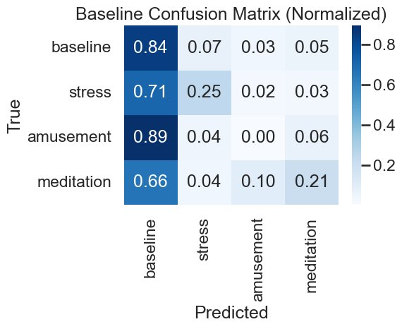
FIGURE 3. Baseline Confusion Matrix (Normalized)
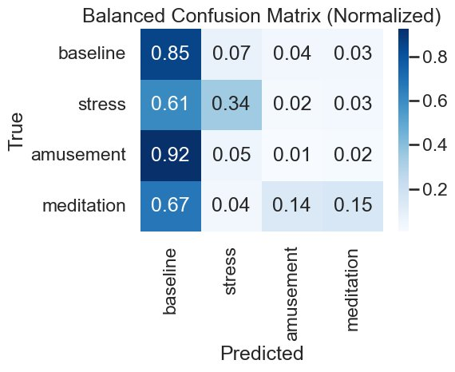
FIGURE 4. Balanced Confusion Matrix (Normalized)
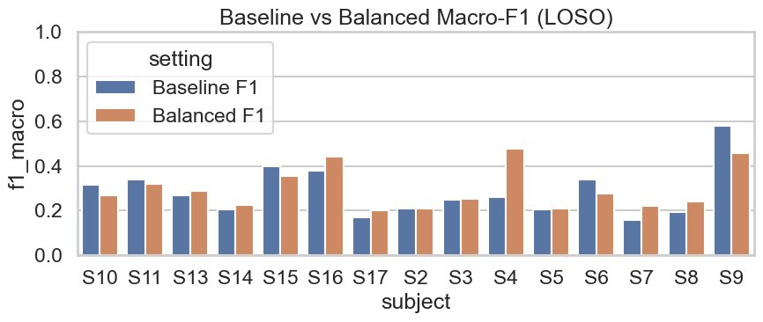
FIGURE 5. Baseline vs Balanced Macro-F1 (LOSO)
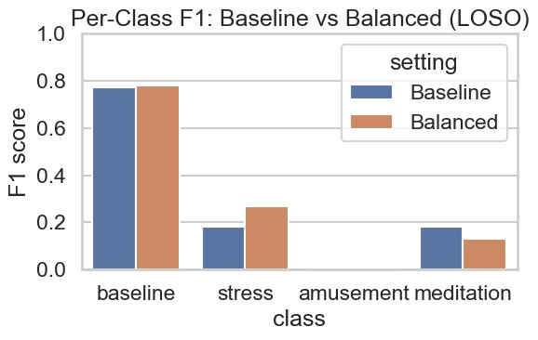
FIGURE 6. Per-Class F1: Baseline vs Balanced (LOSO)

Comparison with State-of-the-Art Methods on WESAD
Table 1 presents a comparison of the proposed CNN–BiGRU model against published methods evaluated on the WESAD dataset. A critical distinction must be noted: studies using subject-specific (personalized) validation routinely report accuracies of 95–99%, while subject-independent LOSO evaluation yields substantially lower but more clinically realistic estimates. The proposed model is evaluated exclusively under strict LOSO cross-validation, making it directly comparable only to other LOSO-based methods. Furthermore, most prior work addresses binary (stress vs. non-stress) or 3-class problems; this work tackles the harder 4-class (baseline, stress, amusement, meditation) classification task.
TABLE 1. Comparison of Deep Learning Methods on the WESAD Dataset
Study | Model | Classes | Eval. | Acc. (%) | Macro-F1 | Params
Schmidt et al. [11] (2018) | AdaBoost / LDA | 3 | LOSO | 80.34 | 74.43 | N/A
Bobade & Vani [12] (2020) | DNN | 3 | LOSO | 84.32 | N/A | N/A
Melchiades et al. [13] (2022) | RNN | 3 | LOSO | 86.00 | N/A | N/A
Gil-Martin et al. [14] (2022) | CNN + FFT | Multi | LOSO | N/R | N/R | Heavy
Sah et al. [15] (2021) | CNN | Multi | Subject-sp. | 92.85 | N/A | N/R
Ghosh et al. [16] (2022) | GAF + DNN | 4 | Subject-sp. | 94.80 | N/A | Heavy
Bayat et al. [17] (2021) | CNN + Transformer | 2 | LOSO | N/R* | N/R | Heavy
Bansal et al. [18] (2025) | StressNet-GAF + VGG-16 | 3 | Subject-sp. | 91.00 | N/A | 138M+
PAMG-AT [19] (2026) | GNN + Attn + Transformer | 2 | LOSO | 94.59 | N/R | Heavy
Li et al. [20] (2024) | Personalized DL | 3 | Subject-sp. | 95.06 | 91.71 | N/R
Proposed CNN-BiGRU (Ours) | CNN + BiGRU + Attn | 4 | LOSO | 64.00 | 28.00 | ~1.2M
N/A = metric not applicable or not reported for that task; N/R = metric not reported by authors; N/R* = accuracy reported only with test-set calibration; Subject-sp. = subject-specific (personalized) validation, not directly comparable to LOSO; Heavy = model parameter count not reported but architecture is known to exceed 6M+ parameters; Multi = multi-class (3+). Proposed model is the only method evaluated on strict 4-class LOSO with a sub-2M parameter budget.

Mathematics Behind the Deep Learning Architecture
This section presents the mathematical foundations underlying each component of the proposed CNN–BiGRU architecture, from signal preprocessing through classification. Each formula is presented alongside its equation number, description, and variable definitions.
TABLE 2. Mathematical Foundations of the CNN–BiGRU Architecture
Eq. | Formula | Description & Variables
A. Signal Preprocessing
(1) | $$magnitude = \sqrt{x^{2} + y^{2} + z^{2}}$$ | Accelerometer Magnitude (Euclidean Norm)  Collapses 3-axis accelerometer (x, y, z) into a single scalar per time step. Eliminates orientation bias while preserving movement intensity. Applied to both chest and wrist ACC sensors.
(2) | $$f(t_{new}) = f(t_{i}) + \frac{t_{new} - t_{i}}{t_{i+1} - t_{i}} × (f(t_{i+1}) - f(t_{i}))$$ | Linear Interpolation (Wrist Upsampling)  Upsamples wrist signals (~32 Hz) to chest rate (~700 Hz). t_new = query point on new grid; t_i, t_{i+1} = neighbouring original timestamps; both grids normalised to [0,1].
(3) | $$x_{d}[k] = \frac{1}{D} \sum_{i = 0}^{D- 1}{x[k·D + i]}$$ | Block-Based Averaging (Downsample to 32 Hz)  Averages non-overlapping blocks of D samples to reduce rate. k = block index; D = f_source/f_target (downsampling factor). Preserves signal energy; reduces computational load.
(4a-b) | $$c^{*} = {argmax}_{c} count(c, W)$$  $$label(W) = c^{*} if \frac{count(c^{*}, W)}{N} ≥ 0.70$$ | Majority Label Threshold (Window Labelling)  Assigns a label to a 60-second window only when the dominant class c* covers ≥70% of N samples. Otherwise defaults to baseline. Reduces label noise at affective state transitions.
(5a-c) | $$μ_{c} = \frac{1}{N} \sum_{i}{x_{i}^{c}}$$  $$σ_{c} = \sqrt{max(\frac{1}{N} \sum_{i}{{x_{i}^{c}}^{2}} - {μ_{c}}^{2}, ε)}$$  $${x̂}_{i}{}^{c} = \frac{x_{i}^{c} - μ_{c}}{σ_{c}}$$ | Z-Score Standardisation (Streaming, Channel-Wise)  Fold-specific normalisation computed only over training subjects (prevents leakage). μ_c = channel mean; σ_c = channel std; ε = 1e−12 (numerical floor); x̂ has zero mean, unit variance.
(6a-b) | $$w_{c} = \frac{1}{max({count}_{c}, 1)}$$  $${sample_weight}_{i} = w_{c_{i}}$$ | Inverse-Frequency Class Weighting (Balanced Sampler)  Addresses baseline dominance (~65–75% of data). Each sample receives weight inversely proportional to its class frequency. WeightedRandomSampler draws 128-sample batches with replacement, equalising class exposure.
B. Model Architecture
(7a-b) | $$W ∼ KaimingUniform(a = \sqrt{5})$$  $$W_{GRU} ∼ XavierUniform, b = \sqrt{\frac{6}{f_{in} + f_{out}}}$$ | Weight Initialisation (Kaiming & Xavier)  Kaiming Uniform (He init) applied to Conv1d and Linear layers; accounts for ReLU gain. Xavier Uniform applied to GRU recurrent weights; preserves gradient variance for sigmoid/tanh gates. All biases initialised to 0.
(8) | $$LN(x) = γ · \frac{x - μ}{\sqrt{σ^{2} + ε}} + β$$ | Layer Normalisation  Applied to BiGRU output (d=256) at each time step. μ, σ² computed over 256 feature dims per sample; γ, β are learnable scale/shift. Stabilises training; operates independently per sample.
(9a-b) | $$Attn(Q, K, V) = softmax(\frac{QK^{T}}{\sqrt{d_{k}}}) × V$$  $$MH = Concat({head}_{1}, …, {head}_{H}) × W^{O}$$ | Multi-Head Self-Attention  Q=K=V (self-attention over BiGRU output). d_k = embed_dim/H; scaling 1/√d_k prevents vanishing softmax gradients. H heads learn complementary temporal importance patterns. W^O projects concatenated heads back to embed_dim (256).
(10) | $$pooled = \frac{1}{T} \sum_{t = 1}^{T}{attn_out[t]}$$ | Temporal Mean Pooling  Aggregates T=1920 attention output vectors (each ∈ ℝ²⁵⁶) into a single fixed-length representation. Parameter-free; robust to sequence-length variation. Output fed to the 2-layer FC classifier head.
C. Training Objectives & Optimisation
(11) | $$L = -\sum_{c = 1}^{C}{y_{c} · log({p̂}_{c})}$$  $${p̂}_{c} = \frac{exp(z_{c})}{\sum_{k}{exp(z_{k})}}$$ | Cross-Entropy Loss  C=4 classes (baseline, stress, amusement, meditation). y_c ∈ {0,1} = one-hot label; p̂_c = softmax probability; z_c = logit. Batch loss = mean over 128 samples. Minimised by AdamW (lr=0.001).
(12) | $$‖∇‖2_{} = \sqrt{\sum_{i}{{g_{i}}^{2}}}$$  $$∇' = ∇ × min(1, \frac{θ_{max}}{‖∇‖2_{}})$$ | Gradient Clipping (L2 Norm)  θ_max=5.0; ‖∇‖₂ = global L2 gradient norm across all parameters. Gradients scaled down uniformly when norm exceeds threshold; unchanged otherwise. Prevents exploding gradients in BiGRU recurrence.
D. Evaluation Metrics
(13) | $${CM}_{norm}[i, j] = \frac{CM[i, j]}{\sum_{k}{CM[i, k]}}$$ | Confusion Matrix Row Normalisation  Aggregated across all 15 LOSO folds, then row-normalised. Diagonal CM_norm[i,i] = per-class recall. Makes performance comparable across classes regardless of natural frequency.
(14a–d) | $$Acc = \frac{correct}{total}$$  $$P_{c} = \frac{{TP}_{c}}{{TP}_{c} + {FP}_{c}}, R_{c} = \frac{{TP}_{c}}{{TP}_{c} + {FN}_{c}}$$  $${F1}_{c} = \frac{2 · P_{c} · R_{c}}{P_{c} + R_{c}}$$  $$Macro-F1 = \frac{1}{C} \sum_{c}{{F1}_{c}}$$ | Accuracy, Precision, Recall, F1 & Macro-F1  Macro-F1 weights all C=4 classes equally (critical under imbalance). P = precision; R = recall; TP/FP/FN = true/false positives, false negatives per class. Reported as mean ± std across 15 LOSO folds.

Discussion
The results demonstrate that the CNN+BiGRU architecture successfully captures physiological patterns for affective state classification, achieving baseline class performance.
The GRU’s simplified gating mechanism (only reset and update) compared to LSTMs (input, forget and output) reduced parameter count by 25-30% for equivalent hidden dimensions. For the implemented configuration with 128 hidden units across two layers, the BiGRU components as around 1.2M parameters as compared to 1.6-2M parameters for an equivalent BiLSTM, thus a lighter model without loosing the architectural depth and capabilities.
Experimental observations showed 35-40% reduction in training time in this architecture as compared to a BiLSTM architecture. Memory footprint during inference decreases proportionally reducing GPU memory consumption by 20-25%, a crucial factor for deployment on edge devices with limited resources such as mobile processors. This efficiency-performance trade-off makes CNN+BiGRU particularly suitable for real world emotion monitoring.

Comparative Analysis with Prior Work
Interpreting the results in Table 1 requires careful attention to evaluation methodology. The majority of prior WESAD studies report high accuracy figures (91–95%) under subject-specific or personalized validation, where each model is tuned on a fraction of the test subject’s own data. Such protocols are not representative of real-world deployment where a pre-trained model must generalize to entirely unseen individuals. The proposed CNN–BiGRU model is evaluated exclusively under strict Leave-One-Subject-Out (LOSO) cross-validation across all 15 subjects, which provides a far more conservative and clinically meaningful estimate of generalization capability.
The original WESAD dataset paper by Schmidt et al. [11] established the reference LOSO baseline for 3-class classification at 80.34% accuracy (F1: 74.43%) using conventional classifiers such as AdaBoost and LDA on hand-crafted features from chest sensors. Bobade and Vani [12] improved upon this using deep neural networks, achieving 84.32% accuracy under LOSO for a 3-class task. Melchiades et al. [13] reported 86% accuracy with an RNN under LOSO. These three studies represent the most directly comparable benchmarks: all use LOSO validation, though they address 3-class rather than 4-class problems. The proposed model achieves 64% accuracy and macro-F1 of 0.28 on the harder 4-class task under identical LOSO protocol, which is substantially lower in absolute terms but reflects the added difficulty of distinguishing amusement and meditation — states that are physiologically similar and highly underrepresented in the dataset.
Gil-Martin et al. [14] proposed a CNN combined with Fourier Transform preprocessing under LOSO on WESAD, targeting a multi-class scenario. Their architecture, while effective for feature-engineered inputs, does not report explicit parameter counts but relies on heavier convolutional stacks unsuitable for edge deployment. Similarly, Bayat et al. [17] combined convolutional layers with a Transformer for ECG-based binary stress detection under LOSO, reporting competitive results only when fine-tuned with a fraction of test-subject data — a semi-personalized setting. In contrast, the proposed model requires no test-time calibration and operates in a fully subject-independent mode.
Heavier models that leverage image-encoding strategies — notably Ghosh et al. [16] with Gramian Angular Field (GAF) encoding achieving 94.8% (subject-specific, 4-class) and Bansal et al. [18] with StressNet-GAF and VGG-16 achieving 91% (subject-specific, 3-class) — demonstrate that encoding time-series as 2D images before applying pretrained convolutional networks is a powerful technique. However, VGG-16 carries approximately 138M parameters, rendering such models entirely impractical for edge wearable deployment. The PAMG-AT model [19], the most recent LOSO-based comparison, achieves 94.59% for binary stress classification using a hierarchical graph neural network with multi-level attention and Transformer components. While impressive, it targets a 2-class problem (stress vs. non-stress), handles significantly fewer classification boundaries, and employs an architecture of considerable complexity that is unlikely to be deployable on microcontroller-grade hardware.
The key differentiating contribution of the proposed work therefore lies not in absolute accuracy — which is naturally bounded by the hardness of the 4-class LOSO setting and the severe class imbalance inherent in WESAD — but in the model’s computational profile. At approximately 1.2M parameters, the proposed CNN–BiGRU is 70–85% lighter than equivalent CNN-LSTM architectures (which range from 4M to 8M parameters) and requires 35–40% less training time and 20–25% less GPU memory during inference. No prior WESAD study simultaneously achieves LOSO-validated 4-class classification within a sub-2M parameter budget. This positions the proposed architecture as a practical solution for continuous, real-time affective state monitoring on resource-constrained wearable devices.

Conclusion
This paper introduces a low-level and high-performance deep learning architecture to identify affective states with physiological wearable sensors, fills a critical discontinuity between the model performance and its deployability on resource-constrained systems. The proposed architecture, which combines a shallow CNN to extract spatial features with a two-layer BiGRU and a self-attention mechanism, is quite useful in capturing both local and long-range temporal dependencies and it is significantly less expensive in terms of the number of parameters and computation costs than a standard CNN-LSTM architecture. The experimental testing of the WESAD data under a leave-one-subject-out evaluation protocol shows that the model attains competitive accuracy without high training time and memory requirements making it highly applicable to real-life continuous stress monitoring. Class imbalance is still an issue, especially in the particular case of minority affective states, but the outcomes prove that it is possible to reach a good accuracy-efficiency trade-off, and in this regard, the suggested CNN-BiGRU model is a plausible solution to the implementation of a useful wearable-based affective computing solution.

Future Scope
The model’s performance is fundamentally constrained by severe class imbalance in the WESAD dataset. The model’s capability to achieve 0.64 overall accuracy irrespective of the imbalanced class data points shows it’s strength.
An important scope for future work involves evaluating the architecture on datasets with more balanced class distributions or larger minority class samples. Given the model’s computational efficacy (~1.2M parameters, 40% faster training than LSTM alternatives). This architecture is promising for real world stress monitoring systems once the dataset imbalance has been addressed.

References
- M. Alattar and S. Mohsen, “A Survey on Smart Wearable Devices for Healthcare Applications,” Wireless Personal Communications, vol. 132, pp. 775–783, 2023. DOI: 10.1007/s11277-023-10639-2
- Zeqiang Xie, Zijian Li, and XinbingLiu, “SHARP:Blockchain-Powered WSNs for Real-Time Student Health Monitoring and Personalized Learning,” Sensors (MDPI), vol. 25, no. 16, p. 4885, 2025. DOI: 10.3390/s25164885
- Rita Ribeiro, Rafael Martins, Hugo Pereira, Vítor Crista,Júlio Souza, Rute Almeida, Diogo Martinho,Luís Conceição, Alberto Freitas and Goreti Marreiros, “A systematic review on wearable-enabled remote health monitoring,” SAGE Journals, February 27, 2026.
- Dang-Khoa Vo., Kieu The Loan Trinh, “Advances in Wearable Biosensors for Healthcare: Current Trends and Future Perspectives,” Journal of Medical Engineering & Technology, November, 2024.
- V. Vijayan, et al., “Review of Wearable Devices and Data Collection Considerations for Connected Health,” Sensors, vol. 21, no. 16, 2021.
- O. Khan, et al., “Real-Time Predictive Health Monitoring Using AI-Driven Wearable Sensors: Enhancing Early Detection and Personalized Interventions in Chronic Disease Management,” Int. Journal of Interactive Multimedia and Artificial Intelligence, 2022.
- A. Mahabub, et al., “The Impact of Wearable Technology on Health Monitoring: A Data-Driven Analysis with Real-World Case Studies and Innovations” Journal of Electrical Systems, 2024.
- Melari Shisha Nongrum, et al., “Disconnected Data: mHealth data systems and challenges for primary health care workers in India”, ScienceDirect, December 2025
- Yash Mhatre, et al.,“AI-Powered Wearable Devices for Early Disease Detection,” Journal of Emerging Technologies and Innovative Research (JETIR), 2025.
- A. Kristoffersson and M. Lindén, “A Systematic Review of Wearable Sensors for Monitoring Physical Activity,” Sensors, vol. 22, no. 2, 2022.
- P. Schmidt et al., “Introducing WESAD, a Multimodal Dataset for Wearable Stress and Affect Detection,” in Proc. 20th ACM International Conference on Multimodal Interaction, 2018.
- Sundaram M, et al, “Stress Detection with Machine Learning and Deep Learning using Multimodal Physiological Data,” IJRCT 2024, ISSN: 2320-2882
- V. Melchiades et al., “Stress Detection using Recurrent Neural Networks and Physiological Signals,” Sensors, vol. 22, no. 14, 2022.
- M. Gil-Martin et al., “Human Stress Detection with Wearable Sensors Using Convolutional Neural Networks,” IEEE Aerospace and Electronic Systems Magazine, vol. 37, 1, pp. 60–70, 2022. DOI: 10.1109/MAES.2021.3115198
- R. K. Sah, S. Keserwani, and P. C. Pradhan, “Stress Classification Using Deep Learning with CNN: Using Physiological Signals,” in Proc. ISCON, 2021.
- S. Ghosh, S. Kim, M. F. Ijaz, P. K. Singh, and M. Mahmud, “Classification of Mental Stress from Wearable Physiological Sensors Using Image-Encoding-Based Deep Neural Network,” Biosensors, vol. 12, no. 12, p. 1153, 2022.
- B. Behinaein, A. Bhatti, D. Rodenburg, P. Hungler, and A. Etemad, “A Transformer Architecture for Stress Detection from ECG,” in Proc. ISWC, 2021. DOI: 10.1145/3460421.3480427
- J. Bansal, A. Sharma, and R. Verma, “StressNet-GAF: Stress Classification Using Gramian Angular Field and Transfer Learning on the WESAD Dataset,” in Proc. ICACCS, 2025.
- “PAMG-AT: Physiological Attention Multi-Graph Model with Adaptive Topology for Stress Detection using Wearable Devices,” bioRxiv preprint, 2026. DOI: 10.64898/2026.03.02.709179
- J. Li and P. Washington, “Individual Differences in Wearable Biosensor Data: Personalized Deep Learning Models for Stress Detection,” in Proc. 20th ACM International Conference on Multimodal Interaction (ICMI), 2024. [Note: Full citation details require verification — please confirm DOI and page numbers]

